**API**

1. Auto create 1 record into DB for default language lang=”en-us” or lang =”jp-ja”?

Image:

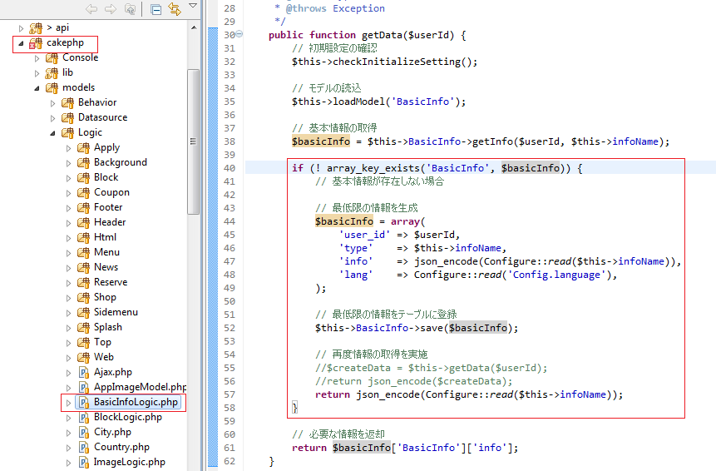

* Path: /iPostSource/cakephp/models/Logic/**BasicInfoLogic.php**
* Function: **getData**
* Source code:

**public function getData**($userId) {

// 初期設定の確認

$this->checkInitializeSetting();

// モデルの読込

$this->loadModel('BasicInfo');

// 基本情報の取得

$basicInfo = $this->BasicInfo->getInfo($userId, $this->infoName);

**if** (! array_key_exists('BasicInfo', $basicInfo)) {

// 基本情報が存在しない場合

// 最低限の情報を生成

$basicInfo = **array**(

'user_id' => $userId,

'type' => $this->infoName,

'info' => json_encode(Configure::*read*($this->infoName)),

'lang' => Configure::*read*('Config.language'),

);

// 最低限の情報をテーブルに登録

$this->BasicInfo->save($basicInfo);

// 再度情報の取得を実施

//$createData = $this->getData($userId);

//return json_encode($createData);

**return** json_encode(Configure::*read*($this->infoName));

}

// 必要な情報を返却

**return** $basicInfo['BasicInfo']['info'];

}